**President’s Message**:

As autumn is upon us streams have been restocked. We look forward to using terrestrials in the cool fresh air and thoughts of upcoming ice fishing

COVID- 19 has had a curtailment on our activities and meetings. We have not had a Banquet/ Fundraiser in two years. However we are planning a Banquet/ fundraiser on April 9 2022 at Lukans Farms and Resort in Hawley As plans progress we will post info on our website pwtu.org.

Thanks to the T U members who participated in the Casting for Recovery Sky Top Retreat, and Members who assisted PA Fish and Boat with the fall stocking.

After 20-something years John Lazar has decided to step down as chapter Treasurer.

Paul Kurinec, long-time Vice President has also stepped down. Several months ago John Hochreither stepped down as chapter webmaster. The Chapter thanks all three men for their years of dedication in a Chapter leadership role.

New Officers:

Vice President- Tony Capitano

Treasurer- Mark Frey

Youth Coordinator – Don Strathy

Webmaster - Gene Shultz

The chapter thanks them for stepping up in their new leadership roles.

Rails and Trails Alliance Honesdale to Hawley submitted two grants to DCNR for enough dollars to complete both river access sites. Included in the application is an ADA fishing pier in White Mills. In November DCND will notify the Alliance if they received the Grant.

We will resume our Chapter monthly

meetings at Cora’s Bistro in Hawley on the second Tuesday of the month, 6:30 pm second floor. I encourage women chapter members to attend our meetings, all are welcome.

**CHAPTER PRESIDENT--Paul Ranello**



**PIKE-WAYNE CALENDAR 2021-22**

*(*General meetings:**SECONDTUESDAY** of the month, at 6:30 p.m.)

**Nov 9- Cora's Bistro-Hawley**

**Dec 14-Christmas Party- Cora's Bistro-Hawley**

**Jan 11, 2022- Cora's Bistro-Hawley**

**Feb 8- Cora's Bistro-Hawley**

**Mar 8- Cora's Bistro-Hawley**

**April 9- PWTU Banquet-Lukan's Resort**

**April 12- Cora's Bistro-Hawley**

***Check PWTU.org* for schedule changes and updated Chapter info)**

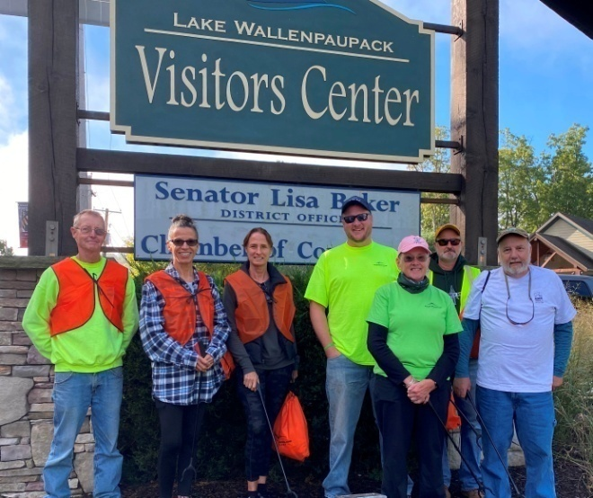

**River and Trail Clean-up Crew**

On Sept 25th the Pocono Mountains Visitors Bureau sponsored a River and Trail Clean-up. The entire 4-county region with the PMVB provided support and rallying locations for volunteers including at the Lake Wallenpaupack Visitors Center (supporting cleanups in Hawley and the lake trail) and Wayne County Visitors Center (supporting cleanups in the borough and along the Lackawaxen River). Thanks to Penn DOT and Keep PA Beautiful, for providing supplies (bags, gloves, vests, etc.).

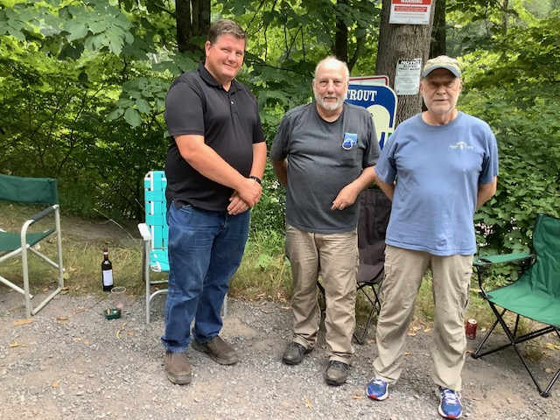

**Mark N., Pres. P. Ranello and V.P. P. Kurinec**

***TROUT in The Classroom***

Mark Nebzydoski Ph.D. *from Western Wayne High School* purchased materials for the aquarium and attended a workshop.  The workshop discussed all of the setup, maintenance and curriculum tie ins.  He will be setting up the tank at the end of October *Many thanks to Larry Ott, TIC Coordinator, and Eric Brad* form the Broadhead Chapter for their assistance with TIC at Western Wayne school District *TROUT in The Classroom . This wiil be the first Trout in the Classroom in The Wayne School District in a long time. PWTU offered their support to the program.*

**Pennsylvania Trout in the Classroom**

## OUR STORY

​Dating back to 2006,  Trout in the Classroom in Pennsylvania began as a non-formal education program, with programs varying among individual teachers and program partners (e.g., local Trout Unlimited chapters, watershed associations, and conservation organizations).  At that time, there were approximately 20-40 teachers implementing TIC. Trout eggs were obtained from hatcheries, either state or private. Formal registration, end-of-year reports, workshops, designated trout release sites, curriculum connections, and a TIC network for teachers/partners did not exist.  
   
Beginning in 2008, the Pennsylvania Fish & Boat Commission (PFBC) and PA Trout Unlimited (PATU) partnered to coordinate and implement the PA TIC program on an organized, statewide scale.  In January of 2008, PFBC hired a TIC Coordinator to coordinate, implement, and manage the PA TIC program statewide by collaborating directly with TIC teachers, program partners, and the PATU Program Director. The Pennsylvania Department of Education provided valuable support in curriculum development.  Through this unique partnership, each organization provides the key resources found throughout this site to make the PA TIC program a success.  
   
Since 2008, the PA TIC program has grown from 90 participants to over 400. The program continues to grow organically due to networks of dedicated teachers and program partners, with personal connections fostered each year between thousands of students and their local waterways.

**(***copied from the Spring 2021 issue of the PATU Newsletter)*

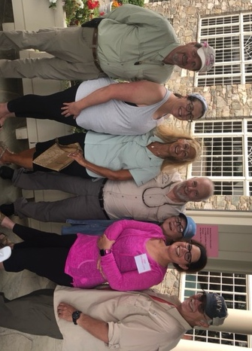

**NCR VOLUNTEERS**

**Nationally Casting For Recovery** is celebrating 25 years in existence. Their mission is to enhance the quality of life of women with breast cancer through a unique retreat program that combines breast cancer education, and peer support with the therapeutic sport of fly fishing.

On September 14th Skytop Lodge hosted the Casting for Recovery Eastern Pennsylvania Retreat.. Participants are selected at random from a pool of applicants. The CFR retreat includes lodging and meals and is offered at no cost to Participants. On the last day of The 2-1/2 day retreat Volunteers from Trout Unlimited Chapters assisted the participants in an enjoyable morning of fly fishing. Special thanks to Ed Burgholzer, Marina Swartz, Paul Ranello, Larry Kirwan, donating their time, making this retreat a wonderful success

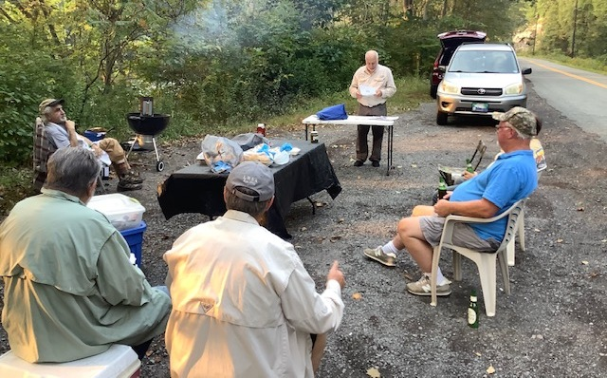

**RIVER MEETING 9-14-21**

**------------------------------**

**PWTU RIVER MEETINGS**

May to August (2nd Tuesday of the month) meetings are on the Lackawaxen River-6:30 p.m. to whenever-**at the 110 mile marker** (upriver from intersection towpath and rt. 590). Just look for a lot of cars and a happy group of guys. We have Bar-B-Q; hamburgers; hot dogs, brats, salads and beverages***. Make sure to bring a folding chair for yourself.***

----------------------------------------

**Our PWTU Mission: The conservation and enhancement of Pike and Wayne counties cold water streams and fisheries.**

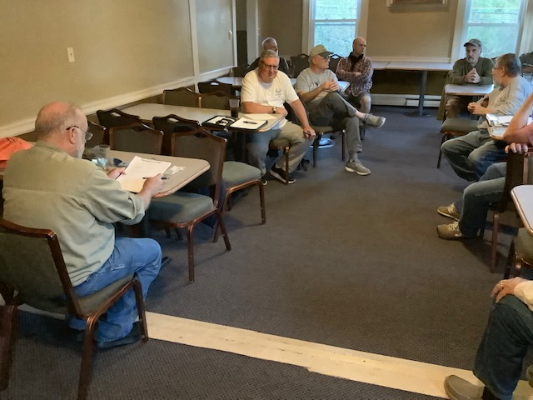

**BACK AT CORA'S BISTRO FOR FALL AND WINTER**

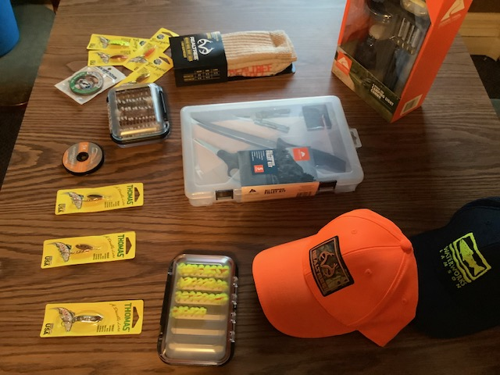

**SOME RAFFLE PRIZES FOR EACH MEETING**

**(NOTE:PWTU PATCHES AND HATS AVAILABLE FOR SALE AT MEETINGS)**

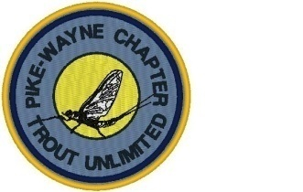

.

**The Creamton Fly Fishing Club**

Located on the Upper West Branch of the Lackawaxen River, Wayne County, PA.

7 miles of private water. Presently accepting potential members for our waiting list.2.5 hrs. from NYC and Philly.

*Reasonable rates.* **Visit us at: www.creamtonflyfishingclub.com**